Samostalno stvaranje priče

Promotri sliku. Na njoj su glavni likovi tvoje buduće priče.  Isplaniraj:  glavni likovi i osobine  ________________________________________________  ________________________________________________  sporedni likovi __________________________________  kompozicija priče  – uvod (mjesto i vrijeme radnje):  _______________________________________________  ________________________________________________  – glavni dio (zaplet):  ________________________________________________  ________________________________________________  _______________________________________________  – završetak (rasplet):  _______________________________________________  ________________________________________________ | 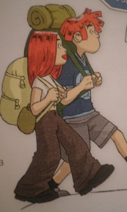
Napiši priču.
____________________________________
__________________________________________________________________________________________________________________________________________________________________________________________________________________________________________________________________________________________________________________________________________________________________________________________________________________________________________________________________________________________________________________________________________________________________________________________________________________________________________________________________________________________________________________________________________________________________________________________________________________________________________________________________________________________________________________________________________________________________________________________________________________________________________________________________________________________

