*Od slova do snova,* čitanka za 2. razred

Nastavna jedinica: ***Branimirov sat***, interpretacija priče, str. 80.

1. Imenuj ove vrste ura (satova):

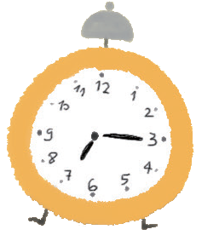 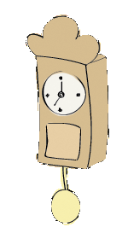 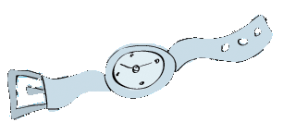

____________________ ____________________ ______________________

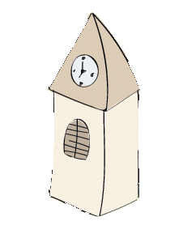 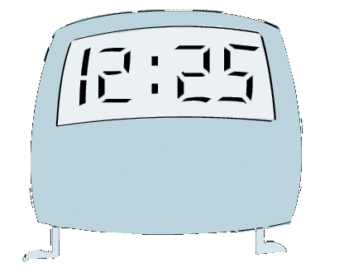 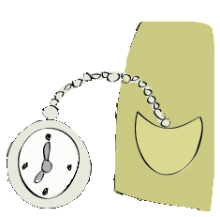

____________________ ____________________ ______________________

2. Što bi se dogodilo kad bi ovi ljudi kasnili na svoj posao? Ispričaj.

PEKARI, VOZAČI, LIJEČNICI, TRGOVCI, UČITELJI

3. U priči se spominje riječ JESENAS. Znaš li što ona znači?

Kojom riječju bismo zamijenili izraze: „prošle zime“, „prošloga proljeća“, „prošloga ljeta“?

__________________________________________________________________________

4. Koju ljudsku osobinu ima Branimirov sat?

___________________________________________________________________________

5. Kada još Branimirov sat postupa kao živo biće?

___________________________________________________________________________

6. Kad bi mogao govoriti, što bi sat rekao Branimiru?

______________________________________________________________________________________________________________________________________________________

7. Što bi tvoj sat (tvoja ura) rekao tebi?

______________________________________________________________________________________________________________________________________________________

8. Kako treba postupiti kad pogriješimo?

______________________________________________________________________________________________________________________________________________________

9. Kako treba postupiti kad zakasnimo?

______________________________________________________________________________________________________________________________________________________

10. Odglumite u razredu situaciju kašnjenja na nastavu.

______________________________________________________________________________________________________________________________________________________