**IME I PREZIME ISTRAŽIVAČA: ____________________________________________________________**

1. Pogledaj videozapis *Kretanje po dnu* na digitalnoj platformi IZZI:

<https://hr.izzi.digital/DOS/580/1955.html>

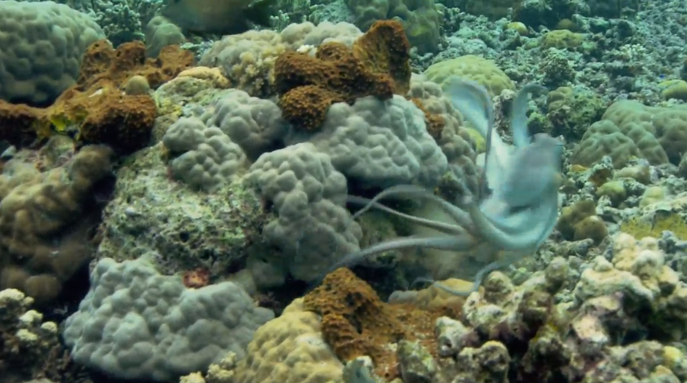

**Na osnovi praćenja videozapisa riješi zadatak.**

**1. Opažaj, bilježi, analiziraj.**

**a)** Koje je morsko područje prikazano? ___________________________________________________________________

**b)** U prazan prostor nacrtaj organizme koje opažaš.

|  |
| --- |
|  |

**c)** Koje organizme prepoznaješ?

___________________________________________________________________

**d)** Ima li alga u ovom morskom području?

___________________________________________________________________

**2. Zaključi.**

**a)** Mogu li organizmi prikazani u videozapisu živjeti u obalnom području? Objasni svoj odgovor.

___________________________________________________________________

__________________________________________________________________

**b)** Postoji li utjecaj čovjeka na organizme prikazane u videozapisu? Objasni svoj odgovor.

___________________________________________________________________

__________________________________________________________________

**Za kraj...**

Riješi križaljku i ponovi što si naučio na moru.

|  |  |  |  |  |  |  |  |  |  |  |  |  |  |  |
| --- | --- | --- | --- | --- | --- | --- | --- | --- | --- | --- | --- | --- | --- | --- |
|  |  |  |  |  |  |  |  |  | **3.** |  |  |  |  |  |
|  |  |  | **1.** | **2.** |  |  |  |  |  |  |  |  |  |  |
|  |  |  |  |  |  |  |  |  |  | **4.** |  |  |  |  |
| **1.** |  |  |  |  |  |  |  |  |  |  |  |  |  |  |
|  |  | **2.** |  |  |  |  |  |  |  |  |  |  |  |  |
|  |  |  |  |  |  |  |  |  |  |  |  |  |  |  |
|  |  |  |  |  |  |  |  |  |  |  |  |  |  |  |
|  |  |  |  |  |  |  |  |  |  |  |  |  |  |  |
|  | **3.** |  |  |  |  |  |  |  |  |  |  |  |  |  |
|  |  |  |  |  |  |  |  |  |  |  |  |  |  |  |
|  |  |  |  |  |  |  |  |  |  |  |  |  |  |  |
| **4.** |  |  |  |  |  |  |  |  |  |  |  |  |  |  |
|  |  |  |  |  |  |  |  |  |  |  |  |  |  |  |
|  |  |  |  |  |  |  |  |  |  |  |  |  |  |  |
|  |  |  |  |  |  |  |  |  |  |  |  |  |  |  |
|  |  |  |  |  |  |  |  |  |  |  |  |  |  |  |
|  |  |  |  |  |  |  |  |  |  |  |  |  |  |  |

Vodoravno:

1. područje u moru
2. plavocrni školjkaši (mn.)
3. morska mijena – spuštanje mora
4. najbrojniji organizmi u moru

Okomito:

1. endemska smeđa alga
2. biljke priobalnoga područja
3. smeđa alga
4. ima kućicu nalik na vulkan