*Od slova do snova 2*, čitanka za 2. razred

**Krampusov oglas**, str. 71.

1. Dopuni rečenice.

Krampus cijeni samo ________________________ djecu.

Kaže da se nitko ne treba stidjeti zbog toga što____________________________.

Ne treba se bojati _____________________________________.

Šibe dobivaju _____________________ i ______________________ djeca.

2. Opiši krampusa.

__________________________________________________________________________________________________________________________________________________________________________________________________________________________________________________________________________________________________________________________________________________________________________________________________________________________________________________________________

3. Bi li se krampus veselio da vidi ovu sobu?

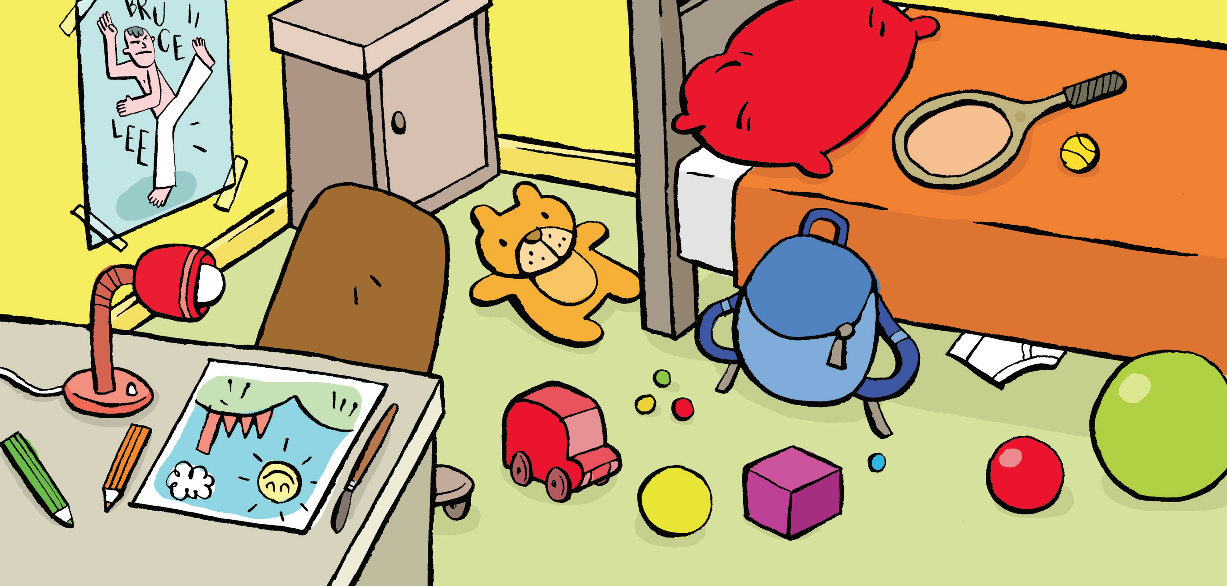

Pogledaj sliku. Točno nabroji što treba učiniti u sobi.

____________________________________________________________________________________________________________________________________________________________________________________________________________________________________________________________________________________________________________

4. Prepiši pjesmu tako da svaku riječ rastaviš na slogove. Radi ovako:

Dje-co, ne slu-šaj-te

Što Ni-ko-la vam ve-li.

________________________________________________________________________________________________________________________________________________________________________________________________________________________________________________________________________________________________________________________________________________________________________________________________________________________________________________________________________________________________________________________________________________________________________________________________________________________________________________________________________________________________________________________________________________________________________________________________________________________________________________________________________________________________________________________________________________________________________________________________________________________________________________________________________________________________________________________________________________________________________________________________________________________________________________