Kune i lipe

1. Kako se zove hrvatski novac?
2. kuna i vrba
3. kuna i lipa
4. lasica i lipa
5. Papirnati oblik novca nazivamo:
6. papirnice
7. novčanice
8. novac.
9. Metalni oblik novca nazivamo:
10. kovanice
11. lipe
12. metalnice.
13. Jedna kuna kraće se piše:
14. 1k
15. 1ku
16. 1 kn.
17. Jedna lipa kraće se piše:
18. 1 lp
19. 1 l
20. 1 lip.
21. Koliko lipa ima jedna kuna?
22. 1 kn = 10 lp
23. 1 kn = 100 lp
24. 1 kn = 1 000 lp
25. Prebroji koliko je kuna na slici.

[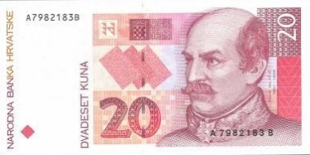](https://www.google.hr/url?sa=i&rct=j&q=&esrc=s&source=images&cd=&cad=rja&uact=8&ved=0ahUKEwijlOz6xejLAhWLXhQKHdfmD7YQjRwIBw&url=https://kolekcionar.eu/index.php?category%3D143&bvm=bv.117868183,d.ZWU&psig=AFQjCNF3hGYVkxKnNE6pZLmeNYzljqVBAA&ust=1459431980923399)[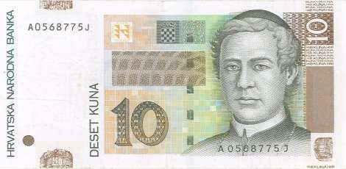](http://www.google.hr/url?sa=i&rct=j&q=&esrc=s&source=images&cd=&cad=rja&uact=8&ved=0ahUKEwjkyPKTxujLAhXGPhQKHS5pBg4QjRwIBw&url=http://www.kunalipa.com/katalog/novcanice/10-kuna.php&bvm=bv.117868183,d.ZWU&psig=AFQjCNFRc4uPwOMmSxmjrbc6kPEj7eo7Bg&ust=1459432037426307)[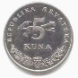](http://www.google.hr/url?sa=i&rct=j&q=&esrc=s&source=images&cd=&cad=rja&uact=8&ved=0ahUKEwjp5rehxujLAhUHVhQKHaduCSQQjRwIBw&url=http://www.kunalipa.com/katalog/kovanice/5-kuna.php&bvm=bv.117868183,d.ZWU&psig=AFQjCNHUNohRXcZ63cjkP0SU0vCLBBZdXA&ust=1459432063967726)[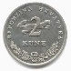](http://www.google.hr/url?sa=i&rct=j&q=&esrc=s&source=images&cd=&cad=rja&uact=8&ved=0ahUKEwi9teOuxujLAhWLWRQKHXkXDE8QjRwIBw&url=http://www.kunalipa.com/katalog/kovanice/2-kune.php&bvm=bv.117868183,d.ZWU&psig=AFQjCNF2lUxtGcOGT_2oopOELyIpG5UN2g&ust=1459432091370885)[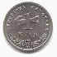](http://www.google.hr/url?sa=i&rct=j&q=&esrc=s&source=images&cd=&cad=rja&uact=8&ved=0ahUKEwjJo4y6xujLAhXFWRQKHRiNB-4QjRwIBw&url=http://www.kunalipa.com/katalog/kovanice/1-kuna.php&bvm=bv.117868183,d.ZWU&psig=AFQjCNFVScMua4U-dGKbbqsb54P1tjJqxQ&ust=1459432117754112)

1. 39 kn
2. 37 kn
3. 38 kn
4. Izračunaj i zaokruži točan odgovor.

65 kn + 27 kn = ?

1. 100 kn
2. 98 kn
3. 92 kn
4. Marija kupuje lutku koja stoji 26 kuna. Prodavačici plaća dvjema novčanicama od po 20 kuna. Koliko kuna mora dobiti natrag od prodavačice?
5. 6 kn
6. 14 kn
7. 20 kn
8. Lina i Luka štedjeli su da mogu kupiti neke igračke. Prije odlaska u dućan na stol su stavili svu ušteđevinu i prebrojali ju. Koliko su novca uštedjeli?

[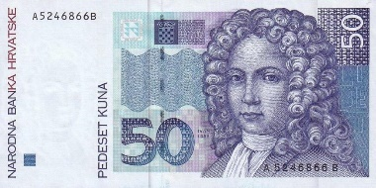](http://www.google.hr/url?sa=i&rct=j&q=&esrc=s&source=images&cd=&cad=rja&uact=8&ved=0ahUKEwiy7ov2xujLAhUKPRQKHX9LATsQjRwIBw&url=http://www.igre123.net/forum/tema/loto-igara-123/29775/&psig=AFQjCNHPF4YIjwKX18nODK6p82oELnJLnQ&ust=1459432239580049)[](http://www.google.hr/url?sa=i&rct=j&q=&esrc=s&source=images&cd=&cad=rja&uact=8&ved=0ahUKEwjkyPKTxujLAhXGPhQKHS5pBg4QjRwIBw&url=http://www.kunalipa.com/katalog/novcanice/10-kuna.php&bvm=bv.117868183,d.ZWU&psig=AFQjCNFRc4uPwOMmSxmjrbc6kPEj7eo7Bg&ust=1459432037426307)

[](http://www.google.hr/url?sa=i&rct=j&q=&esrc=s&source=images&cd=&cad=rja&uact=8&ved=0ahUKEwjp5rehxujLAhUHVhQKHaduCSQQjRwIBw&url=http://www.kunalipa.com/katalog/kovanice/5-kuna.php&bvm=bv.117868183,d.ZWU&psig=AFQjCNHUNohRXcZ63cjkP0SU0vCLBBZdXA&ust=1459432063967726)[](http://www.google.hr/url?sa=i&rct=j&q=&esrc=s&source=images&cd=&cad=rja&uact=8&ved=0ahUKEwi9teOuxujLAhWLWRQKHXkXDE8QjRwIBw&url=http://www.kunalipa.com/katalog/kovanice/2-kune.php&bvm=bv.117868183,d.ZWU&psig=AFQjCNF2lUxtGcOGT_2oopOELyIpG5UN2g&ust=1459432091370885)[](http://www.google.hr/url?sa=i&rct=j&q=&esrc=s&source=images&cd=&cad=rja&uact=8&ved=0ahUKEwjJo4y6xujLAhXFWRQKHRiNB-4QjRwIBw&url=http://www.kunalipa.com/katalog/kovanice/1-kuna.php&bvm=bv.117868183,d.ZWU&psig=AFQjCNFVScMua4U-dGKbbqsb54P1tjJqxQ&ust=1459432117754112)[http://www.kunalipa.com/katalog/slike/kovanice/lipa-50-a.jpg](http://www.google.hr/url?sa=i&rct=j&q=&esrc=s&source=images&cd=&cad=rja&uact=8&ved=0ahUKEwiLhr-jx-jLAhWDVxQKHXtWA5UQjRwIBw&url=http://www.kunalipa.com/katalog/kovanice/50-lipa.php&bvm=bv.117868183,d.ZWU&psig=AFQjCNEX-AU662OC43E19JDA_MIGn_8T-Q&ust=1459432338729268)C:\Users\MajaJ\AppData\Local\Microsoft\Windows\INetCache\Content.Word\20 lipa.pngC:\Users\MajaJ\AppData\Local\Microsoft\Windows\INetCache\Content.Word\20 lipa.pngC:\Users\MajaJ\AppData\Local\Microsoft\Windows\INetCache\Content.Word\10 lipa.pngC:\Users\MajaJ\AppData\Local\Microsoft\Windows\INetCache\Content.Word\10 lipa.pngC:\Users\MajaJ\AppData\Local\Microsoft\Windows\INetCache\Content.Word\10 lipa.png

1. 90 kn 90 lp
2. 91 kn 20 lp
3. 92 kn 10 lp