1. Nabroji višekratnike broja 100.

_____________________________________________________________________

1. Koji su višekratnici broja 100 manji od 800, a veći od 300?

_____________________________________________________________________

1. Koja se stotica nalazi:
2. neposredno ispred broja 1 000? ________________________________________
3. neposredno iza broja 600? _______________________________________
4. Dopuni nizove:
5. 200, 300, _____ , _____ , _____ , _____ , _____ , _____, 1000
6. 400, 401, _____ , _____ , _____ , 405 , _____ , _____, _____
7. 600, 610, _____ , _____ , _____ , _____ , _____ , 670, _____
8. 370, 371, _____ , _____ , _____ , _____ , _____ , _____, 378
9. 790, 800, _____ , _____ , 830 , _____ , _____ , _____, _____
10. Popuni tablice.

|  |  |  |  |  |  |
| --- | --- | --- | --- | --- | --- |
| 7 S 2 D 3 J |  |  | | | |
|  |  | šesto sedamdeset devet | | | |
|  | 358 |  | | | |
|  |  |  | |  |  |
| Broj za 1 manji |  | 504 | |  |  |
| Broj | 881 |  | |  | 277 |
| Broj za 1 veći |  |  | | 1000 |  |
|  |  |  | |  |  |
|  | 28 |  |  | | 985 |
| 5 · 10 + 0 ·1 |  |  | 4 ∙ 100 + 6 ∙ 10 + 2 ∙ 1 | |  |
|  | 74 |  |  | | 393 |

1. Tina je od mame dobila haljinu. Mama je haljinu platila s dvije novčanice od 100 kuna, s pet novčanica od 10 kuna i sa sedam kovanica od 1 kune. Koliko je mama platila haljinu?

R: ___________________________________________________________________

O: ___________________________________________________________________

___________________________________________________________________

1. Usporedi brojeve:

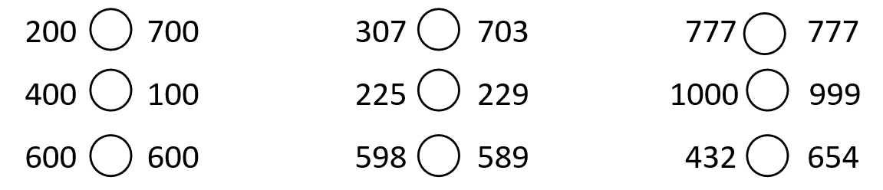

1. Izračunaj nepoznati broj:

63 + x = 98 y – 17 = 46 a ∙ 9 = 81 56 : b = 8

x = __________ y = __________ a = __________ b = _________

x = _____ y = _____ a = _____ b = _____

1. a) Kada broj 48 podijelimo nepoznatim brojem dobit ćemo broj 8. Koji je to

nepoznati broj?

R: ____________________ O: ___________________________________

____________________ ___________________________________

____________________

b) Kada od nepoznatog broja oduzmemo broj 38 dobit ćemo broj 46. Koji je to

nepoznati broj?

R: ____________________ O: ___________________________________

____________________ ___________________________________

____________________

1. Izračunaj.

|  |  |  |
| --- | --- | --- |
| 100 + 100 = _____ | 684 + 3 = _____ | 349 – 7 = _____ |
| 500 + _____ = 800 | _____ + 7 = 349 | _____ – 4 = 685 |
| _____ + 200 = 600 | 287 + 3 = _____ | 990 – 8 = _____ |
| 1 000 – 300 = _____ | 753 + 9 = _____ | 485 – 6 = _____ |
| _____ – 400 = 200 | _____ + 6 = 892 | _____ – 3 = 228 |