1. SLOŽI SLOVA REDOM.

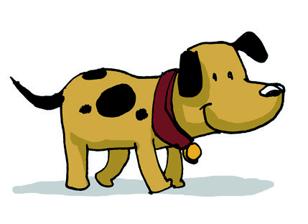 |  | S |  | A |  | P
 |  | I |  | Š |  | M
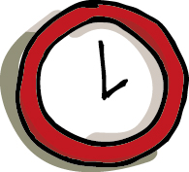 |  | R |  | A |  | U
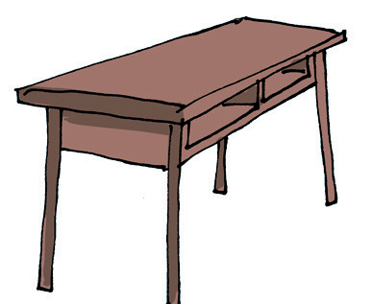 |  | L |  | S |  | O |  | T
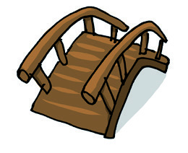 |  | S |  | M |  | O |  | T

