SLOVO R

ŠTO VIDIŠ NA SLIKAMA?

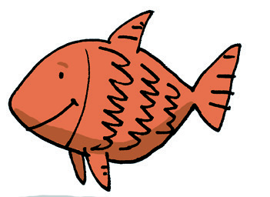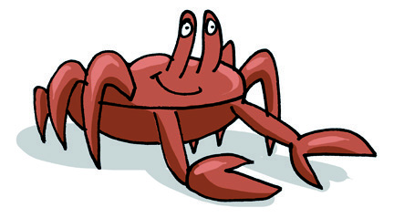

KOJIM GLASOM POČINJU TE RIJEČI?

DOPUNI RIJEČI SLOVOM KOJE NEDOSTAJE.

|  |  |  |  |  |  |  |  |  |
| --- | --- | --- | --- | --- | --- | --- | --- | --- |
| C:\Users\Korisnik\AppData\Local\Microsoft\Windows\Temporary Internet Files\Content.Word\torta.jpg | | | C:\Users\Korisnik\AppData\Local\Microsoft\Windows\Temporary Internet Files\Content.Word\brod.jpg | | | C:\Users\Korisnik\AppData\Local\Microsoft\Windows\Temporary Internet Files\Content.Word\roda.jpg | | |
| TO |  | TA | B |  | OD |  |  | ODA |

OBOJI SVA SLOVA R.