**RADNI LISTIĆ: TIJEK EVOLUCIJSKE MISLI**

**1.** Popuni tablicu.

|  |  |  |
| --- | --- | --- |
|  | Lamarck | Darwin |
| promjenjivost vrsta (da/ne) |  |  |
| evolucijski čimbenici |  |  |

**2.** Na temelju slika odgovori na pitanje. Kako po Lamarcku objašnjavaš teoriju evolucije prema kojoj žirafe imaju dugi vrat, a kako to objašnjavaš po Darwinu?

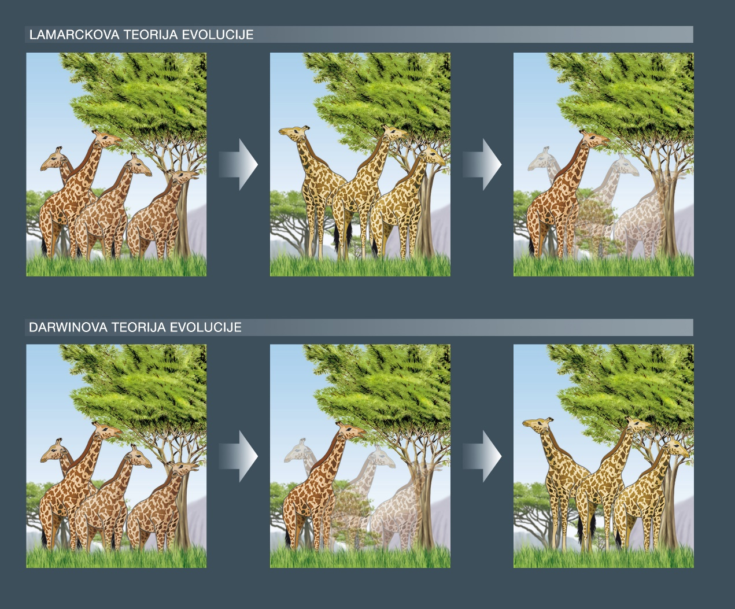

__________________________________________________________________________

__________________________________________________________________________

__________________________________________________________________________

**3.** Na čijoj se teoriji može temeljiti sljedeća tvrdnja? Osoba koja ide redovito u teretanu, ima jake mišiće i to obilježje prenosi na potomke. Objasni svoj odgovor.

__________________________________________________________________________

__________________________________________________________________________

__________________________________________________________________________

**4.** Koja teorija objašnjava postupnu pojavu plivaće kožice ili duge noge ptica močvarica? Objasni svoj odgovor.

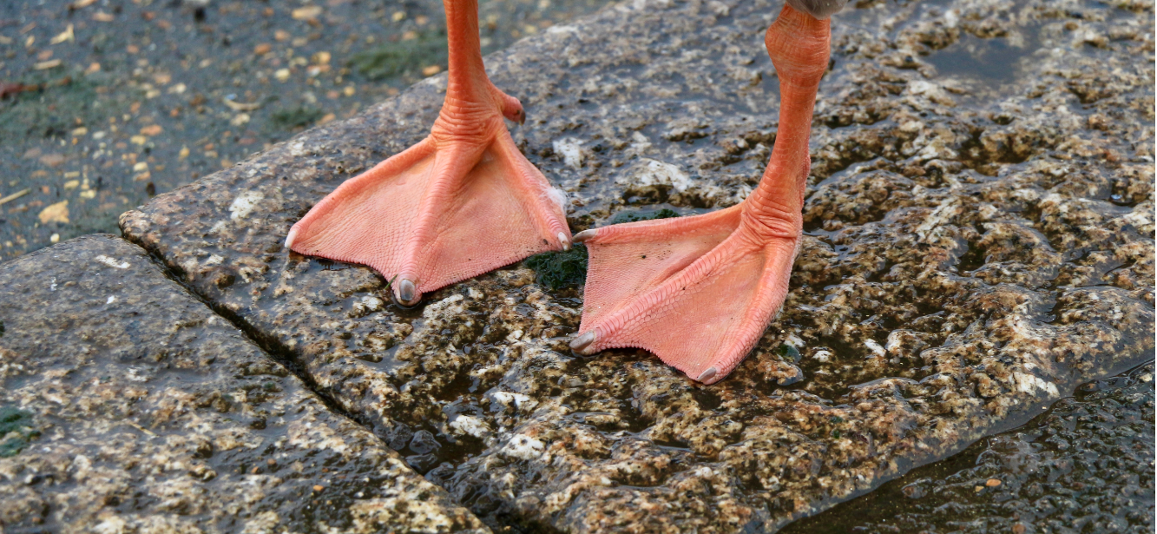

__________________________________________________________________________

__________________________________________________________________________

__________________________________________________________________________

Pripremile: Branka Horvat, prof. i Antonija Korač Šubaša, prof.