**Rukopisna slova (do slova F)**

**1. Poveži sliku i riječ. Riječi zapiši u crtovlje pisanim slovima.**

**krafna semafor fotoaparat**

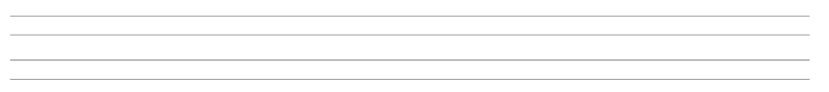



**2. Promatraj slike i odgovori na pitanja. Piši rukopisnim slovima.**

**Što radi Fran?**



**Što radi Fanika?**

**Što svira Filip?**