TRAG U PRIČI 3


PREHLAĐENI SNJEGOVIĆ, Nada Iveljić
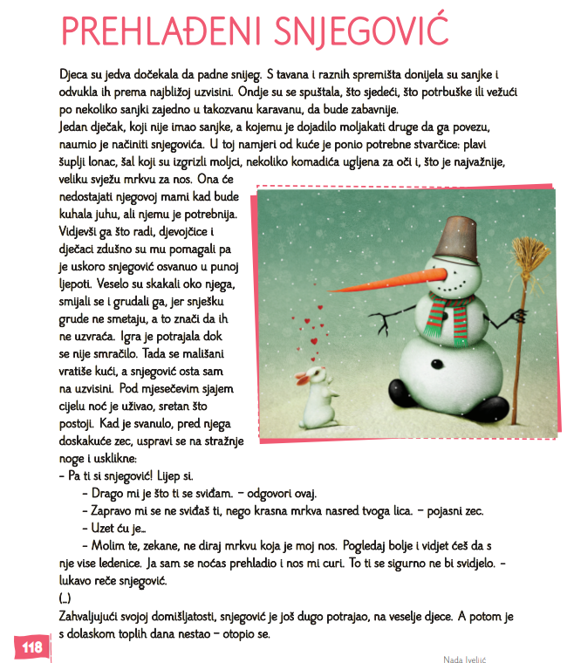
https://carnet-my.sharepoint.com/:p:/g/personal/vesna_stipic1_skole_hr/ES0Wn1m0W2NKtb5dVlxUHjEBZ0lhvD6naLKlIxHAoJnPug?e=rKlvUh

Pripremila: Vesna Stipić, OŠ Nikole Hribara, Velika Gorica

